Meat on Wheels iOS App
Design Document

Version 1.0



Group Id: F2102293DD

Supervisor Name: Hafiz Muhammad Haroon

Revision History

Date (dd/mm/yyyy) | Version | Description | Author
06-02-2022 | 1.0 | The main purpose of this iOS app is to provide fresh meat at home. As we know in the Covid-19 pandemic everybody was bounded at home and not able to get meat even shop owners were at loss during a pandemic. Covid-19 has changed the shopping landscape in many ways, the most apparent in the fact that many people now would instead buy meat and other food supplies online. Nowadays, we can purchase anything online. It’s also possible to skip the queues at the supermarket or in the butchers and buy meat online. | BC180202258  MC190401868

Table of Contents

- Introduction of Design Document
- Entity Relationship Diagram (ERD)
- Sequence Diagrams
- Architecture Design Diagram
- Class Diagram
- Database Design
- Interface Design
- Test Cases

- Introduction to Design Document
We've included ERD, Sequence and Class Diagrams, Database and Interface Design, and Test Cases in this paper. The system requirements, system and subsystem architecture, processing logic, and external interface are all described in the design document. The major goal of this is to formally document software design. It is easier to reuse code that has been well documented. It encapsulates crucial design decisions such as responsibilities, which drive performance. By specifying the interface of the linked modules, it facilitates software integration and unit testing.

- Entity Relationship Diagram (ERD
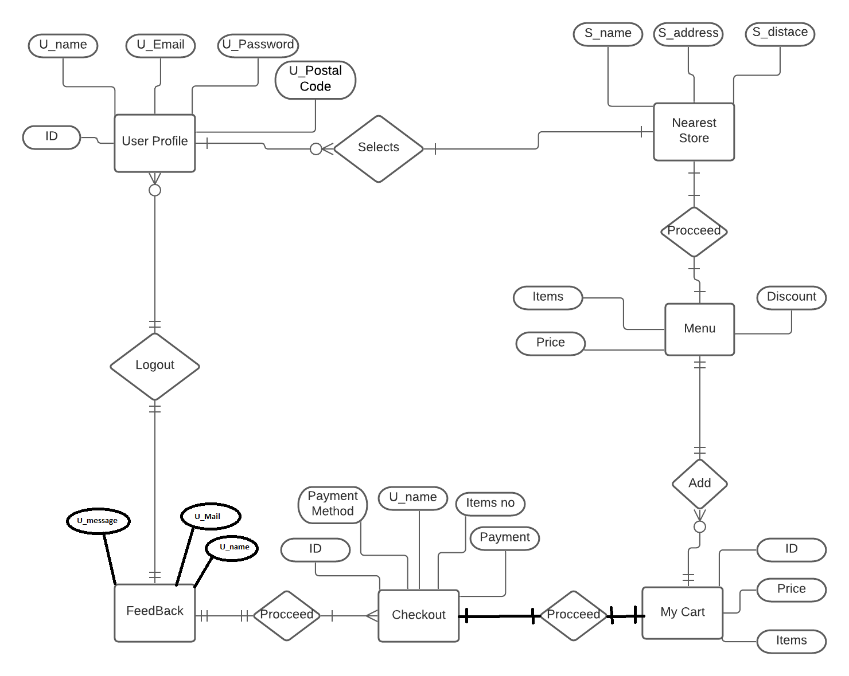

- Sequence Diagrams
- Sequence Diagram For User Registration
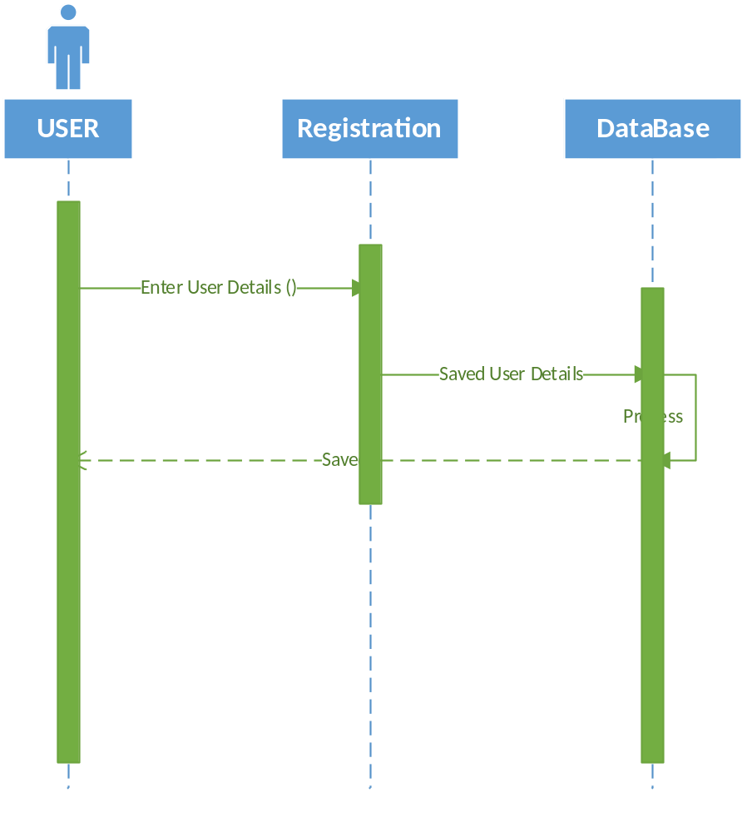

- Sequence Diagram for User Login Interface
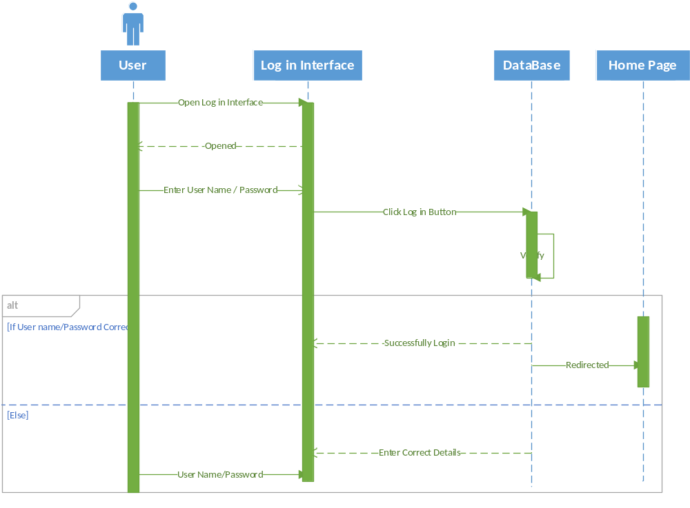

- Sequence Diagram of Choosing Store and Items
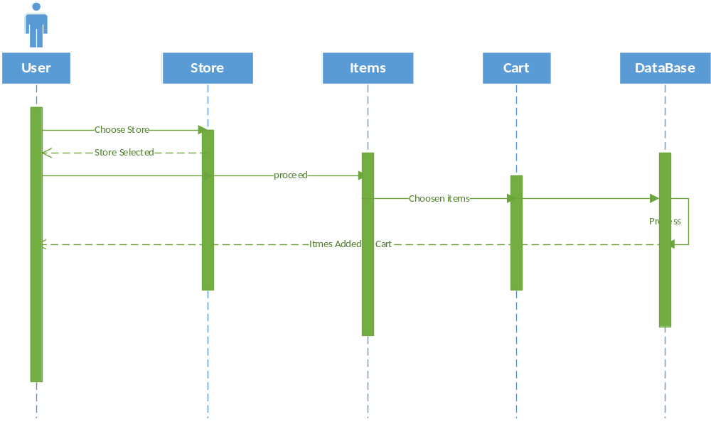

- Sequence Diagram of Checkout and Feedback
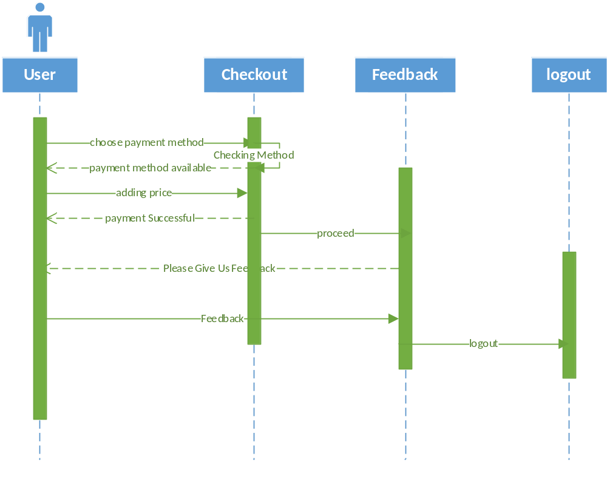

- Architecture Design Diagram

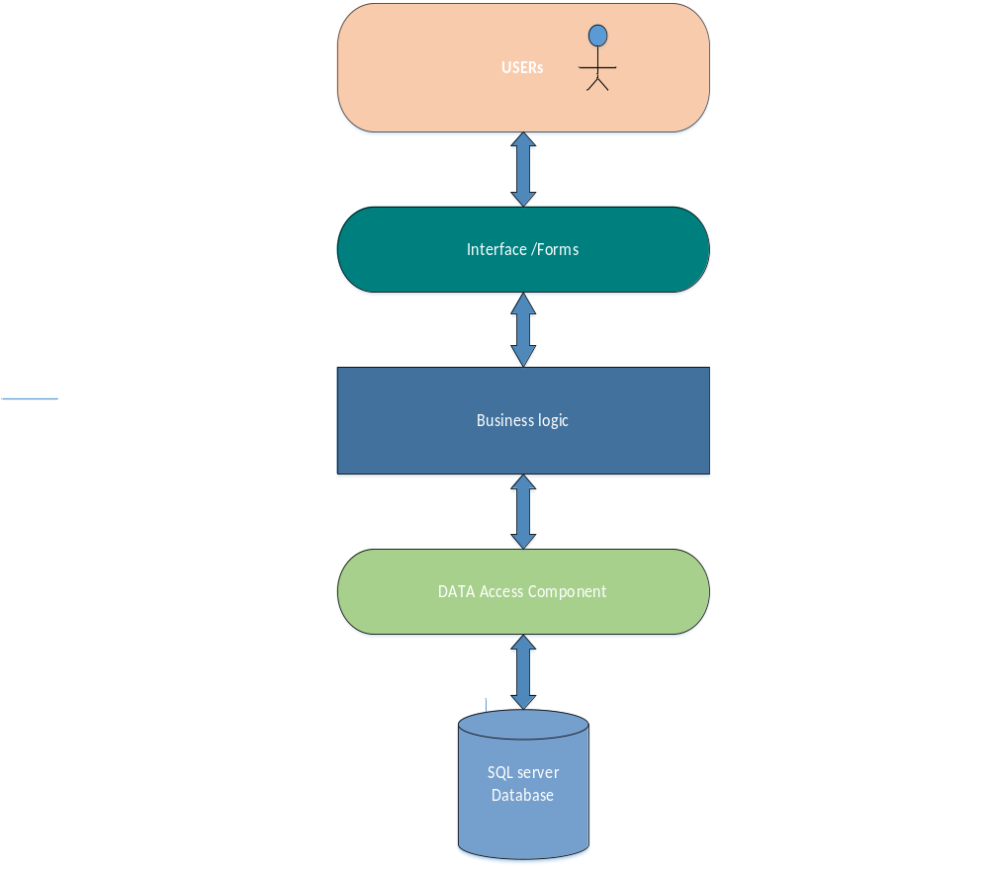

- Class Diagram

- Database Design

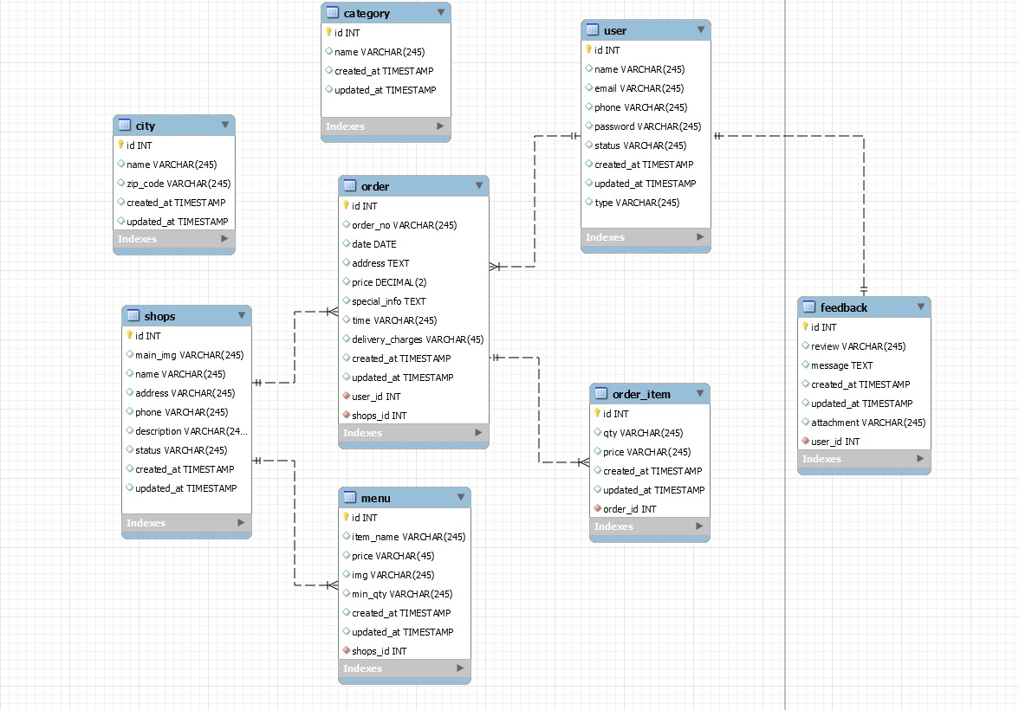

- Interface Design

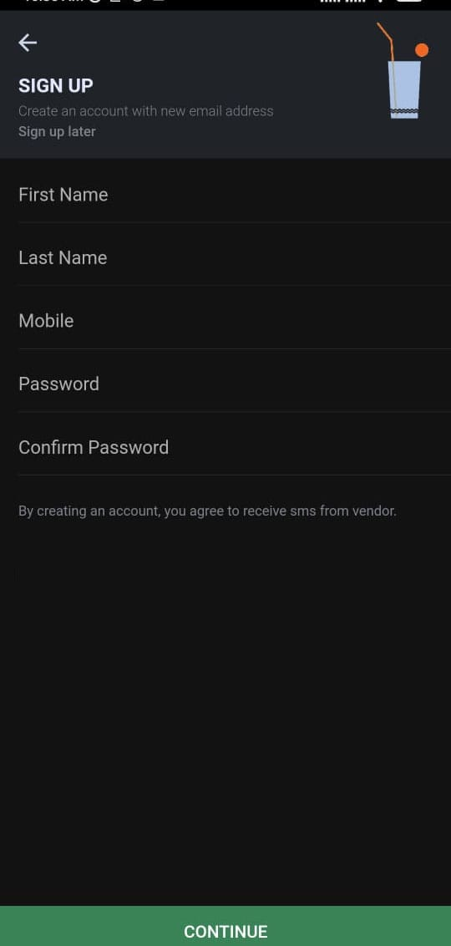

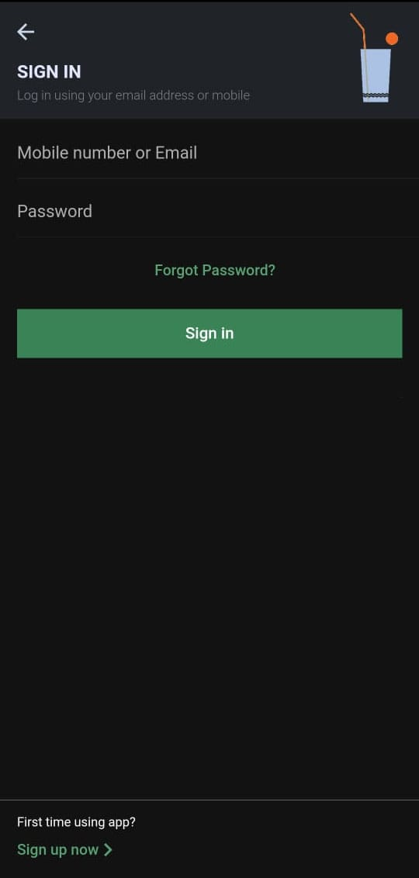
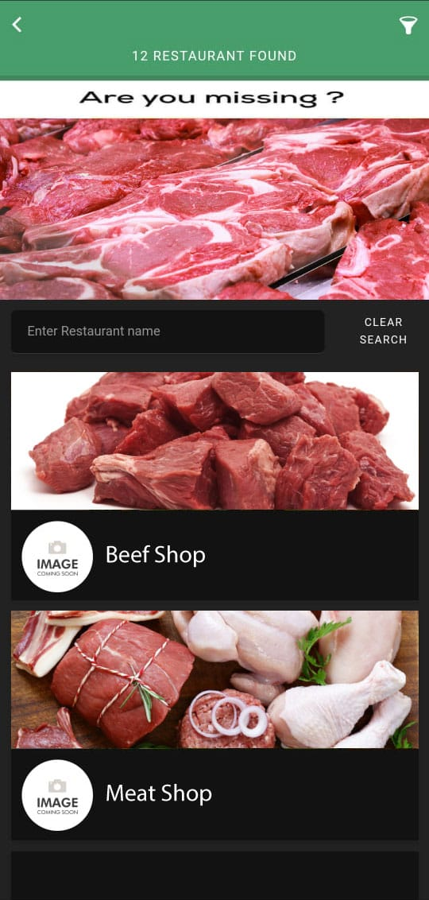
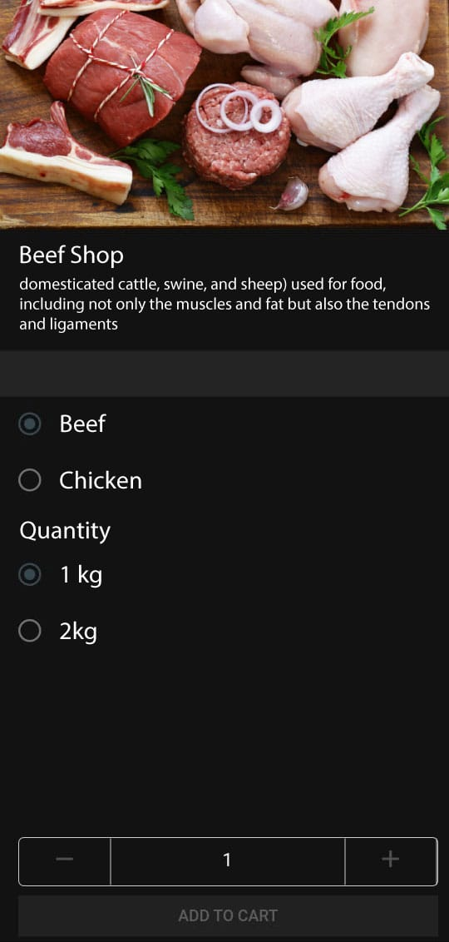
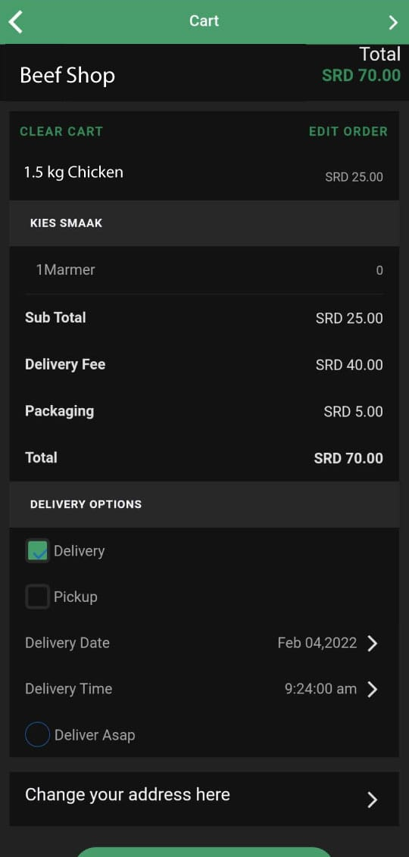

- Test Cases

Test Case No 1
Test Case Title | Testing the Registration Mechanism of the System.
Preconditions | Make a member of the system by Registration in the system.
Actions | Click the Register button on the Login page.
Expected Results | System Should Register New User into the System.
Tested By:
Result | Pass

Test Case No 2
Test Case Title | Testing the Login Mechanism of the System.
Preconditions | User Should Register itself first.
Actions | Click the Login button on the Signing in Form.
Expected Results | System Should Allow New User to log in.
Tested By:
Result | Pass

Test Case No 3
Test Case Title | Testing whether the System tells us about the nearest store or not.
Preconditions | The user Should be logged in first.
Actions | Click the find store button.
Expected Results | The system Should find the nearest store.
Tested By:
Result | Pass

Test Case No 4
Test Case Title | Adding items to Cart.
Preconditions | User Should select the Store first.
Actions | Add different items.
Expected Results | The system Should allow the users to add the items to the cart.
Tested By:
Result | Pass

Test Case No 5
Test Case Title | Checking out.
Preconditions | The user Should be logged in first.
Actions | Click the Checkout button.
Expected Results | The system Should Accept the payment.
Tested By:
Result | Pass

Test Case No 6
Test Case Title | Giving Feedback.
Preconditions | The user Should be logged in first.
Actions | Click the feedback button.
Expected Results | System Should allow user to give feedback.
Tested By:
Result | Pass

